Telenet Incentive Plan
E-Care Tool
Manual

TABLE OF CONTENTS

1. Introduction 2
2. Workflow TIP 2
3. Employer section 2
3.1. Log in to the application 2
3.2. Employee management 2
3.2.1. Overview employees 2
3.2.2. Add individual employee 2
3.2.3. Add number of employees (via XLS sheet) 2
3.2.4. Remove employee from plan 2
3.2.5. Transfer employee from one plan to another within the same entity (swap) 2
3.2.6. Transfer employee to another plan within a different entity 2
3.3. Overview plans 2
3.4. Reporting 2
4. Employee section 2
4.1. Existing Telenet customers 2
4.2. New Telenet customers 2
5. Role of Customer Care 2

Introduction

This application enables you, as employer, to manage your employee base online. Any change you make will the next day be reflected in the reporting. In addition, your employees will now also register online.

For employees who have no e-mail address, the employer will have to provide for a central business desk, where the employee can go through the whole procedure and approve the conditions via the online tool.

Workflow TIP
The following figure shows the (electronic) workflow used in TIP, for both employer and employee:

Modified flow for employees WITH NO e-mail address:

Employer section

Once your contract has been processed, Telenet will send you a personalised mail with your password and login for access to the application.

Re: subscription to <name plan>

Dear Customer,
Please find below your personal login and password for access to your personalised webtool.
Webtool url: https://tip.telenet.be/employer/
Login <username employer>
Password <password employer>

With this tool you can perform the following tasks:
1. add employees to a plan
2. remove employees from a plan
3. transfer an employee from one plan to another
4. reporting
Should you have any questions, please do not hesitate to contact our customer service at 015/364 364(from 9 am to 5 pm) or via mail customercare@telenetgroup.be.

Kind regards
Customer Operations
Telenet Business

Log in to the application

First, log in to the URL provided. https://tip.telenet.be/employer/
Then enter your login and password.

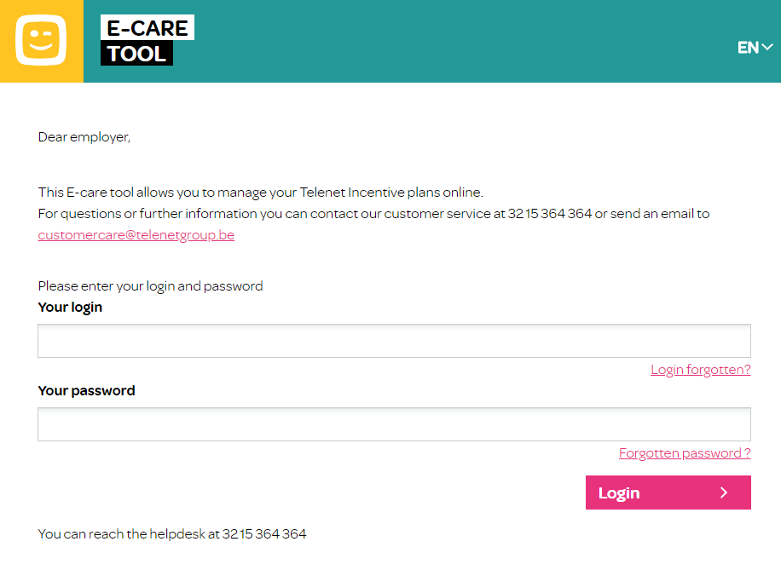

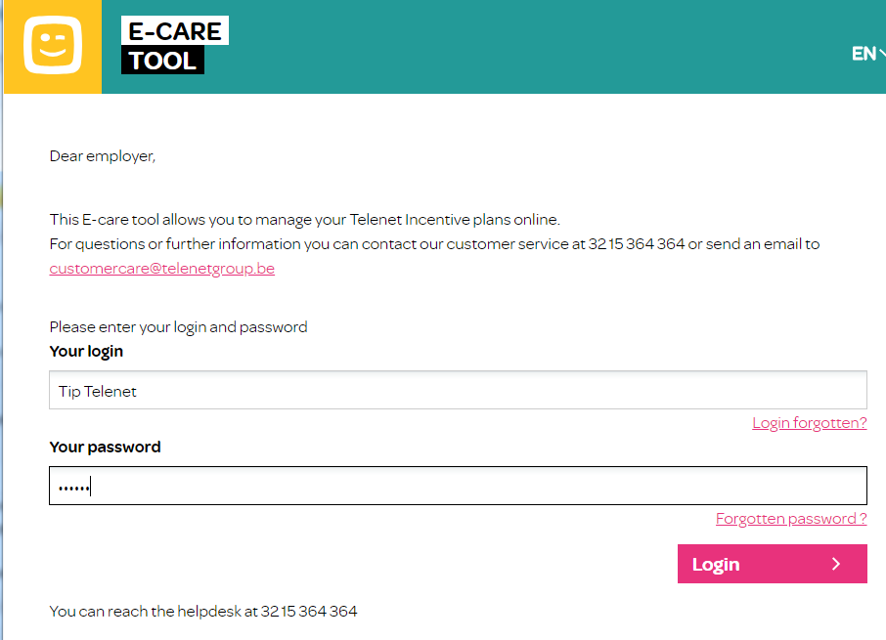

After login you are prompted to change your password the first time.

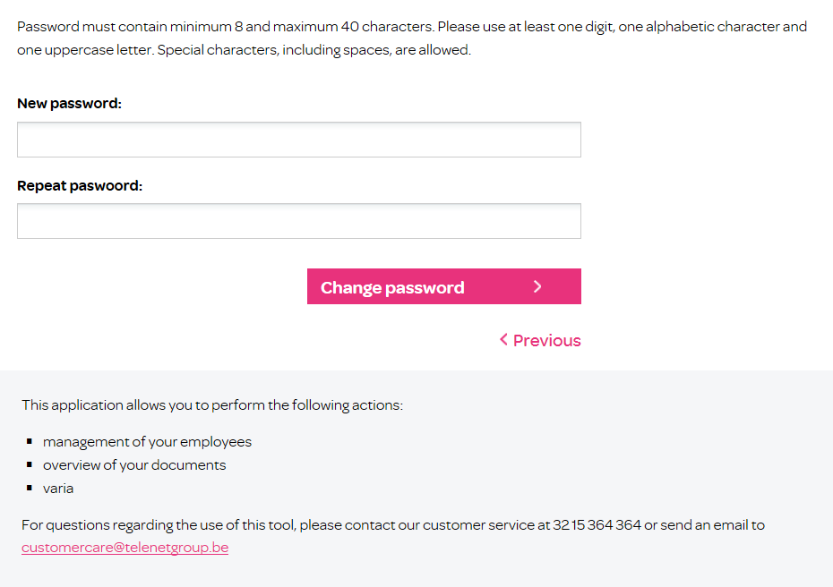

Employee management

The main menu has 3 levels:
- Employee management
  - Overview of employees
    - remove employee from plan
    - remove employee from one plan and add to another plan (SWAP)
  - Add number of employees via an XLS sheet
  - Add individual employee

- Documents
  - overview of contribution plans

- Miscellaneous
  - Change password
  - Extra documentation
  - Reporting

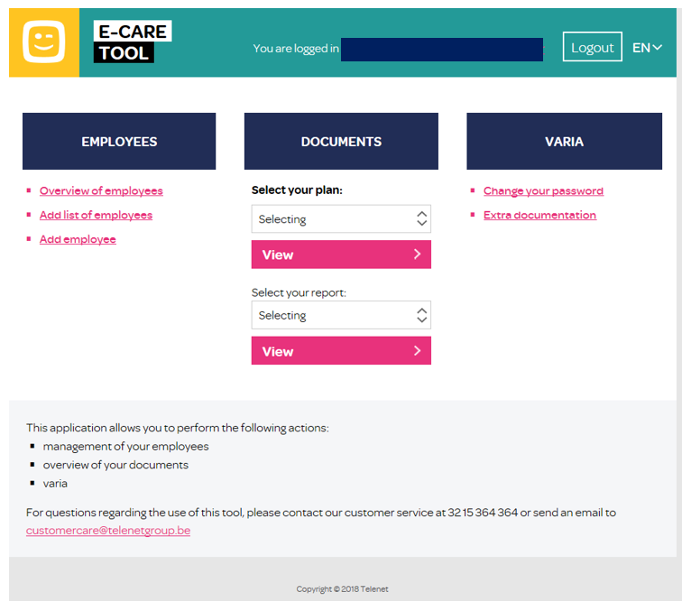

3.2.1. Overview employees
This screen shows an overview of all employees that benefit from the contribution or for which the contribution remains to be processed. You can sort this list by ID (personnel reference chosen by you) / name / plan / status / language.

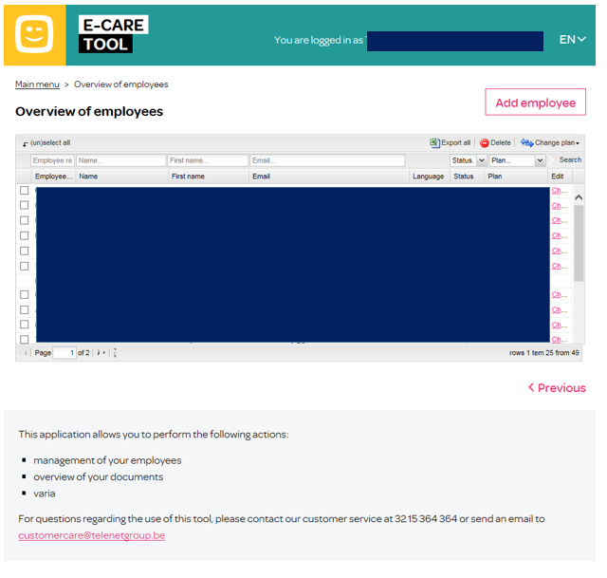

The “Change” button allows you to change the following personnel data:

- name
- first name
- personnel number
- language

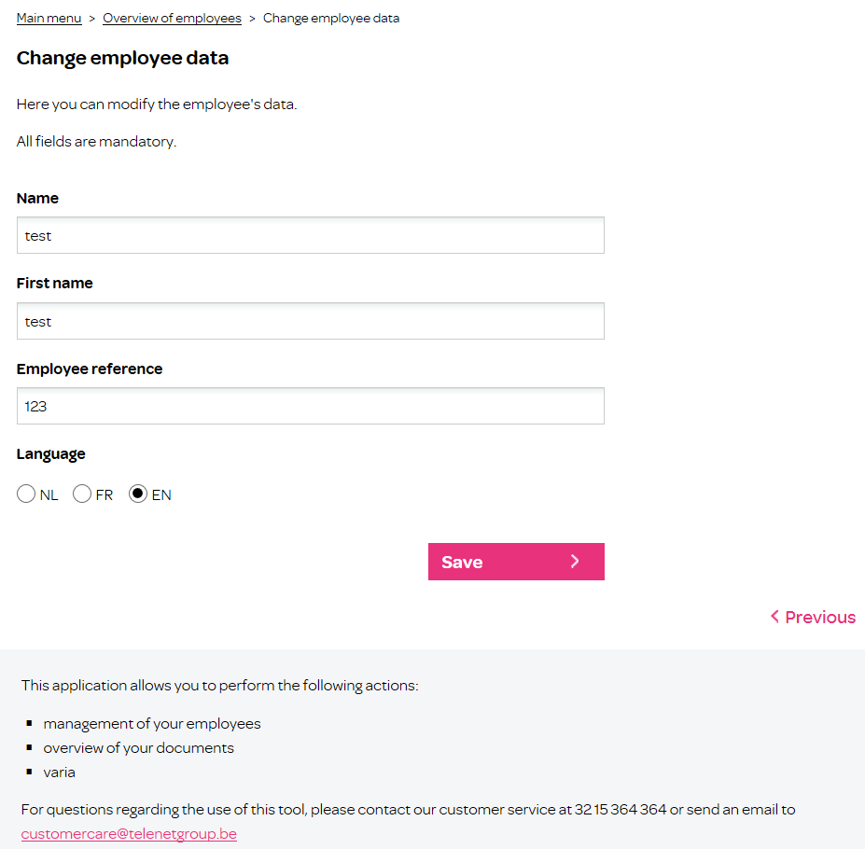

Add individual employee

You can add employees from 2 screens:

- From the main menu:
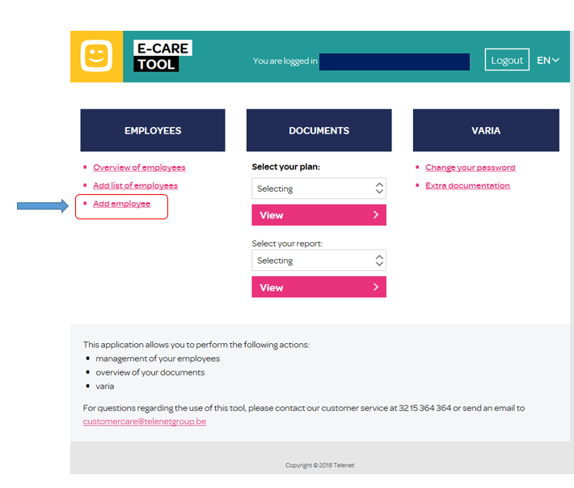
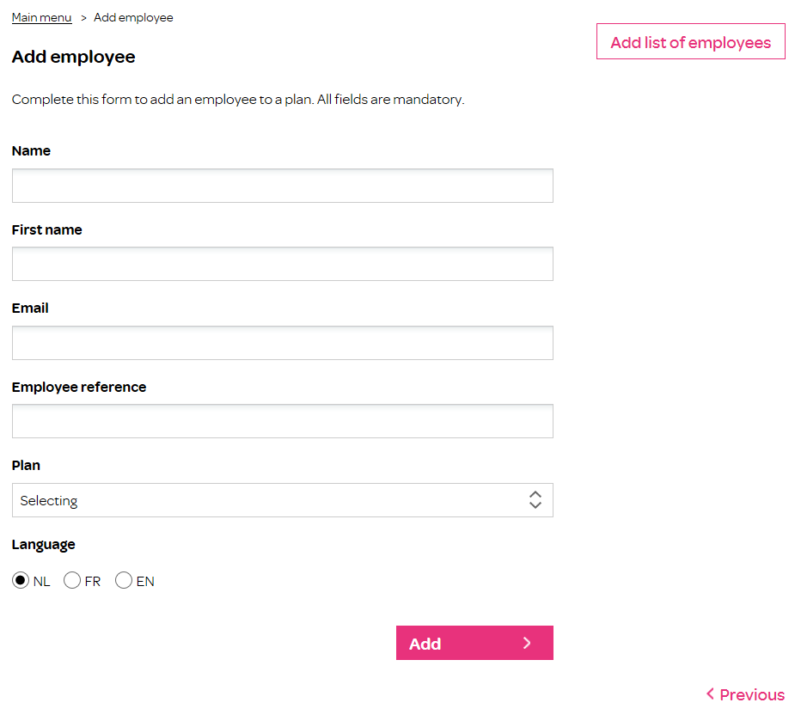

- From the Overview employees screen:

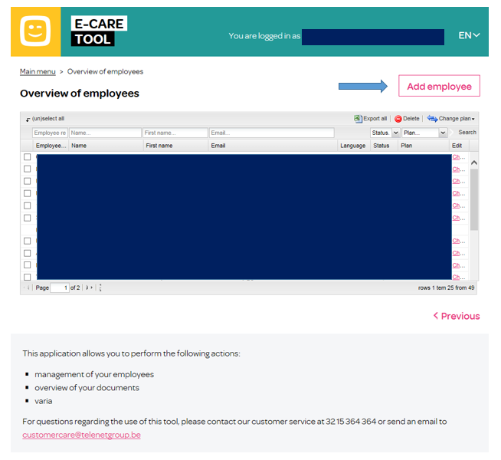

All fields in these screens have to be filled out to allow your employee to benefit from your contribution. Based on the information specified in these fields, Telenet will send your employee a personalised e-mail with a URL where he can register his products and activate the contribution.

If the employee has no personal e-mail address, you enter the central business desk e-mail address in the “e-mail” field.

Add number of employees (via XLS sheet)

This option allows you to input a group of employees in one operation, rather than each employee individually. To compile the list, you can use the attached Excel template. First, you select the plan to which your employees belong. Then you upload the XLS sheet. You can store this sheet on your own drive, so it can afterwards be uploaded to the tool via the browser.

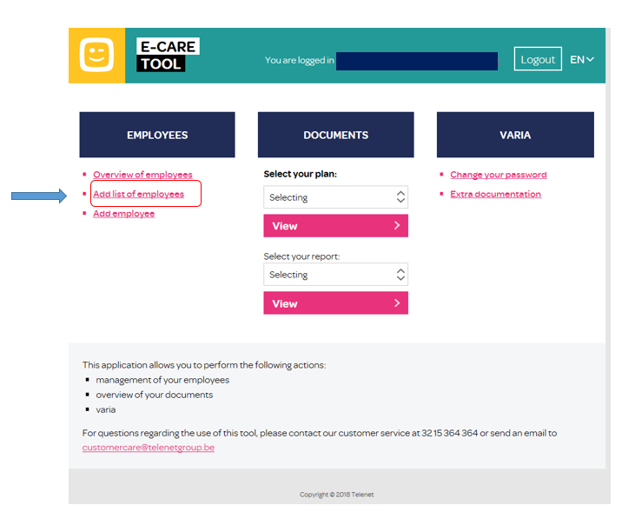

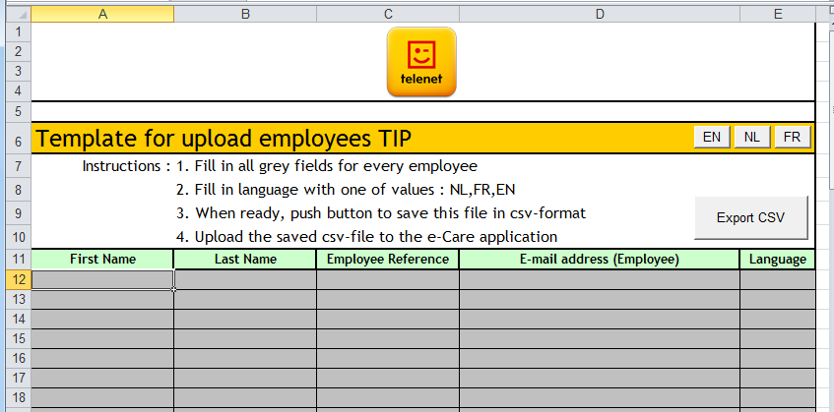

Here, too, you enter the central business e-mail address in the “e-mail” field if the employee has no personal e-mail address.

Then you click on the “upload” button. A confirmation screen will appear with the number of employees that have been added to the selected plan. If no employees could be added, you will receive a message to that effect. You will then have to resubmit the request. Should you encounter any problems, you can contact TIP customer care at 02/300 44 55.

You can also verify the data. Adjust the data, if necessary, and then click on ‘Upload’.

Remove employee from plan

Via the ‘Overview employees’ screen you can easily remove employees from a plan. Select one or more employees for which you no longer wish to pay a contribution. The contribution will automatically be stopped from the next invoice.

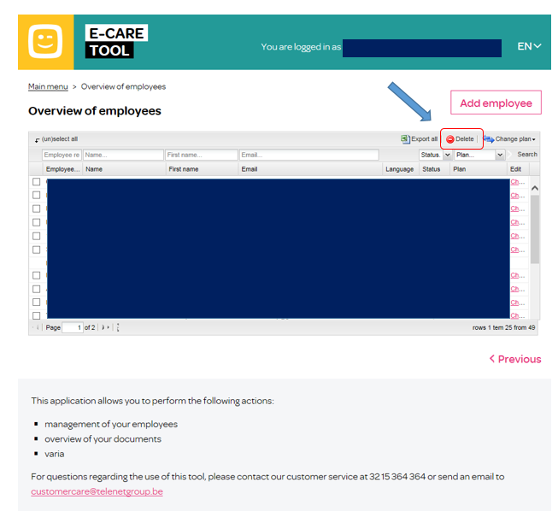

Transfer employee from one plan to another within the same entity (swap)

If you wish to change contribution of an employee, you easily transfer that employee from one contribution plan to another.
Select the employee you want to swap, and then select the new plan.
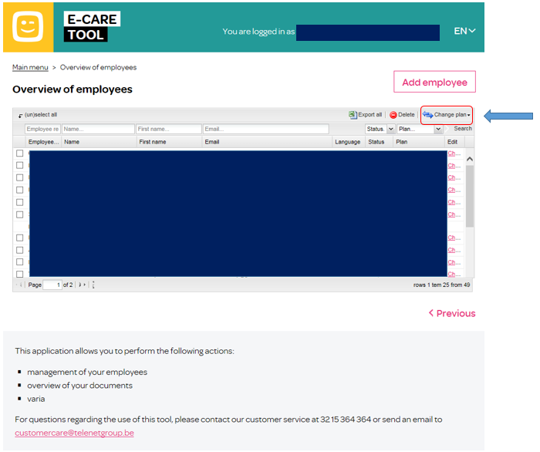

Your employee will be sent an e-mail with the URL where he must accept the new conditions.

If the employee has no personal e-mail address, an e-mail will be sent to the central business desk e-mail address, with as ‘subject’ the name of the relevant employee.

Transfer employee to another plan within a different entity

Swapping within a different entity (company with different VAT No.) is not possible in the way described in 3.2.5.

You must transfer your employee from one contract to the other.

You must remove the employee from the first plan and add him to the other.

To transfer an employee from one contribution plan to the other within a different entity, you must first remove that employee from the first plan and add him to the other.

Overview plans

This screen shows an overview of the contribution plans applicable to your company. These plans can be viewed in detail.
If you want to add a new plan, you must contact your account manager.

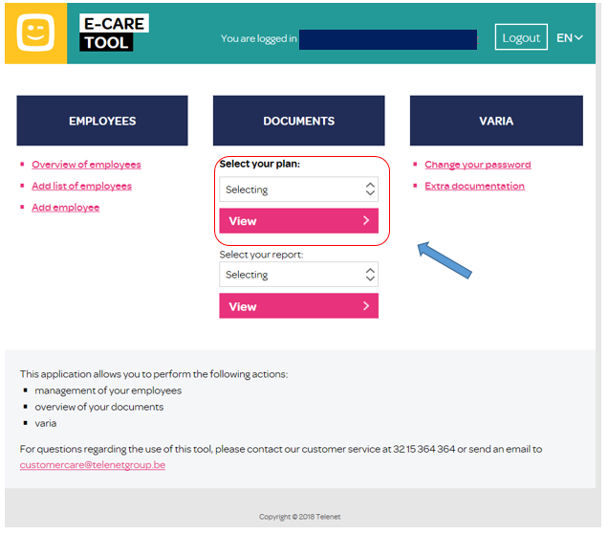

Reporting

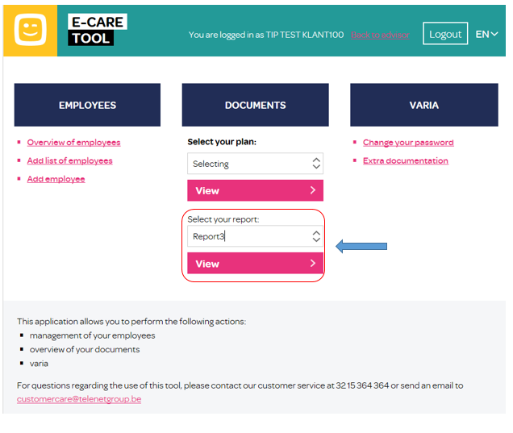

Employee section

Employees who are eligible for the benefits of the plan will receive a personalised mail with the URL where they can register. It is important that your employees go through all the steps of this process, as they need to give their approval to the conditions stipulated by you, and to the transfer of their Internet subscription for the full term of the agreement. Any modification to this agreement has to be approved by your employees.

For employees who have no personal e-mail address, an e-mail will be sent to the specified central business desk e-mail address, with as subject the name of employee, where the employee can go through all the steps of the process online.
On the webtool a distinction will be made between existing Telenet customers and new Telenet customers.

Existing Telenet customers
They will be prompted to specify the customer number and account number to which the contribution will be charged. The employee can find this data on his monthly billing account. No further intervention is required, the contribution will apply from the next invoice.

New Telenet customers
They will receive an e-mail with a unique registration code. With this code, they must contact our Customer Service at 0800/66860 to register their products. The contribution will apply from the first invoice.

Role of Customer Care

Should you have any questions regarding the use of the webtool, please contact the Customer Care department

Phone : 015/364 364(working days from 9 a.m. to 5.30 p.m.)
Fax : 015/364 365
e-mail : customercare@telenetgroup.be

